Practical No :1
Aim: Implement Breadth First Search Algorithm & Iterative Depth First Search Algorithm.
- To implement the Breadth First Search algorithm to solve a given problem.
- To implement the Iterative Depth First Search algorithm to solve the same problem.
- Compare the performance and efficiency of both algorithms.
Program for BFS:
from collections import deque def bfs(graph, start): visited = set() queue = deque([start]) while queue:
vertex = queue.popleft() if vertex not in visited: visited.add(vertex) print(vertex) # Explore neighbors neighbors = graph[vertex] for neighbor in neighbors: if neighbor not in visited: queue.append(neighbor) # Example usage graph = { 'A': ['B', 'C'],
'B': ['A', 'D', 'E'],
'C': ['A', 'F'],
'D': ['B'],
'E': ['B', 'F'],
'F': ['C', 'E'] } start_vertex = 'A' bfs(graph, start_vertex)
Output:
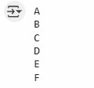
Program for Iterative Depth First Search Algorithm:
from collections import defaultdict class Graph:
def __init__(self):
self.graph = defaultdict(list) def add_edge(self, u, v): self.graph[u].append(v) self.graph[v].append(u) # Assuming an undirected graph def iterative_dfs(self, start, end): if start == end: return [start] visited = set() stack = [(start, [start])] while stack:
current_vertex, path = stack.pop() visited.add(current_vertex) for neighbor in self.graph[current_vertex]: if neighbor not in visited: if neighbor == end:
return path + [neighbor] stack.append((neighbor, path + [neighbor])) return None # No path found # Example usage: if __name__ == "__main__":
g = Graph()
g.add_edge(1, 2)
g.add_edge(1, 3)
g.add_edge(2, 4)
g.add_edge(2, 5)
g.add_edge(3, 6)
g.add_edge(3, 7)
g.add_edge(4, 8)
g.add_edge(4, 9)
g.add_edge(5, 10)
g.add_edge(5, 11)
g.add_edge(6, 12)
g.add_edge(6, 13)
g.add_edge(7, 14)
g.add_edge(7, 15) start_node = 1 end_node = 9
shortest_path = g.iterative_dfs(start_node, end_node) if shortest_path: print(f"Shortest path from {start_node} to {end_node}: {shortest_path}") else:
print(f"No path found from {start_node} to {end_node}") Output:


Practical No :2
Aim: A* Search and Recursive Best-First Search
- Implement the A* Search algorithm for solving a path finding problem.
- Implement the Recursive Best-First Search algorithm for the same problem.
- Compare the performance and effectiveness of both algorithms.
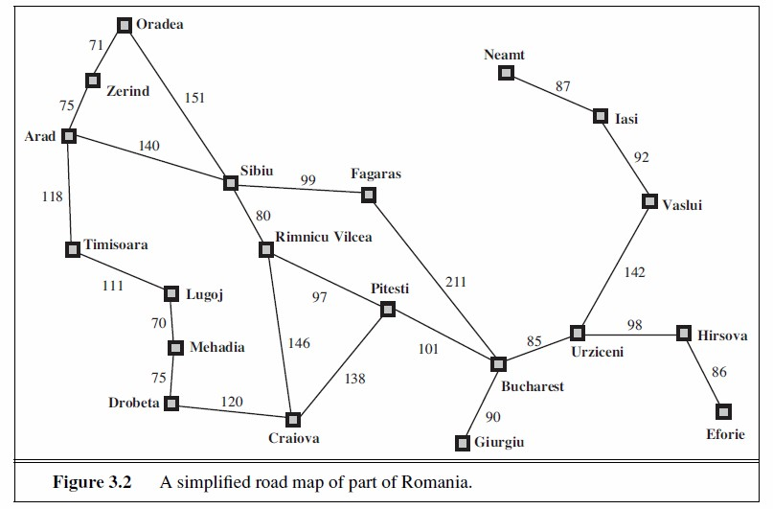
Program:
import heapq # For using a priority queue (min-heap)
# Romania Map: Each city maps to its neighbors and the distance to them romania_map = { 'Arad': {'Zerind': 75, 'Sibiu': 140, 'Timisoara': 118},
'Zerind': {'Arad': 75, 'Oradea': 71},
'Oradea': {'Zerind': 71, 'Sibiu': 151}, 'Sibiu': {'Arad': 140, 'Oradea': 151, 'Fagaras': 99, 'Rimnicu Vilcea':
80},
'Timisoara': {'Arad': 118, 'Lugoj': 111},
'Lugoj': {'Timisoara': 111, 'Mehadia': 70},
'Mehadia': {'Lugoj': 70, 'Dobreta': 75},
'Dobreta': {'Mehadia': 75, 'Craiova': 120},
'Craiova': {'Dobreta': 120, 'Rimnicu Vilcea': 146, 'Pitesti': 138},
'Rimnicu Vilcea': {'Sibiu': 80, 'Craiova': 146, 'Pitesti': 97},
'Fagaras': {'Sibiu': 99, 'Bucharest': 211},
'Pitesti': {'Rimnicu Vilcea': 97, 'Craiova': 138, 'Bucharest': 101}, 'Bucharest': {'Fagaras': 211, 'Pitesti': 101, 'Giurgiu': 90, 'Urziceni':
85},
'Giurgiu': {'Bucharest': 90},
'Urziceni': {'Bucharest': 85, 'Hirsova': 98, 'Vaslui': 142},
'Hirsova': {'Urziceni': 98, 'Eforie': 86},
'Eforie': {'Hirsova': 86},
'Vaslui': {'Urziceni': 142, 'Iasi': 92},
'Iasi': {'Vaslui': 92, 'Neamt': 87},
'Neamt': {'Iasi': 87}
}
# Heuristic: Straight-line distance from each city to Bucharest heuristic = { 'Arad': 366, 'Bucharest': 0, 'Craiova': 160, 'Dobreta': 242, 'Eforie':
161, 'Fagaras': 178, 'Giurgiu': 77, 'Hirsova': 151, 'Iasi': 226, 'Lugoj':
244,
'Mehadia': 241, 'Neamt': 234, 'Oradea': 380, 'Pitesti': 98, 'Rimnicu
Vilcea': 193, 'Sibiu': 253, 'Timisoara': 329, 'Urziceni': 80, 'Vaslui': 199, 'Zerind':
374
}
# Node class to represent each city in the search class Node: def __init__(self, city, parent=None, g=0, h=0):
self.city = city # Current city name self.parent = parent # Parent node (used to trace back the path) self.g = g # Cost from start to this city self.h = h # Heuristic cost to goal self.f = g + h # Total cost = actual + estimated
def __lt__(self, other): return self.f < other.f # Needed for heapq to compare nodes by f value
# A* search function def a_star_search(start, goal):
open_list = [] # Cities to explore (priority queue) heapq.heappush(open_list, Node(start, None, 0, heuristic[start])) # Add start node closed_set = set() # Cities already explored
while open_list: current = heapq.heappop(open_list) # Get the city with lowest f cost
if current.city == goal: # If goal is reached
path = [] total_cost = current.g while current:
path.append(current.city) # Trace back path from goal to start current = current.parent return path[::-1], total_cost # Return reversed path and total cost
closed_set.add(current.city) # Mark current city as visited
# Explore each neighbor of current city for neighbor, cost in romania_map[current.city].items(): if neighbor in closed_set: continue # Skip if already visited
g = current.g + cost # New cost from start to neighbor h = heuristic[neighbor] # Heuristic to goal from neighbor neighbor_node = Node(neighbor, current, g, h) # Create new node
# Check if neighbor is already in open_list with better f skip = False for node in open_list: if node.city == neighbor and node.f <= neighbor_node.f:
skip = True break
if not skip: heapq.heappush(open_list, neighbor_node) # Add neighbor to queue
return None, float('inf') # If goal not reachable
# Main program: Find path from Arad to Bucharest if __name__ == "__main__": start_city = "Arad" goal_city = "Bucharest" path, cost = a_star_search(start_city, goal_city)
if path:
print("Path found:") print(" -> ".join(path)) # Display path step-by-step print("Total cost:", cost) # Display total distance else:
print("No path found.") Output:
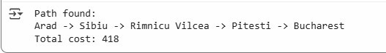
Program for Recursive Best-First Search algorithm
import math # Heuristic: straight-line distance to Bucharest (used as h(n)) heuristics = { 'Arad': 366, 'Zerind': 374, 'Oradea': 380, 'Sibiu': 253, 'Timisoara':
329,
'Lugoj': 244, 'Mehadia': 241, 'Drobeta': 242, 'Craiova': 160, 'Rimnicu
Vilcea':193,
'Fagaras': 178, 'Pitesti': 98, 'Bucharest': 0, 'Giurgiu': 77,
'Urziceni': 80,
'Hirsova': 151, 'Eforie': 161, 'Vaslui': 199, 'Iasi': 226, 'Neamt': 234
} # Graph: roads with costs between cities romania_map = { 'Arad': {'Zerind': 75, 'Timisoara': 118, 'Sibiu': 140},
'Zerind': {'Arad': 75, 'Oradea': 71},
'Oradea': {'Zerind': 71, 'Sibiu': 151}, 'Sibiu': {'Arad': 140, 'Oradea': 151, 'Fagaras': 99, 'Rimnicu Vilcea':
80},
'Timisoara': {'Arad': 118, 'Lugoj': 111},
'Lugoj': {'Timisoara': 111, 'Mehadia': 70},
'Mehadia': {'Lugoj': 70, 'Drobeta': 75},
'Drobeta': {'Mehadia': 75, 'Craiova': 120},
'Craiova': {'Drobeta': 120, 'Rimnicu Vilcea': 146, 'Pitesti': 138},
'Rimnicu Vilcea': {'Sibiu': 80, 'Craiova': 146, 'Pitesti': 97},
'Fagaras': {'Sibiu': 99, 'Bucharest': 211},
'Pitesti': {'Rimnicu Vilcea': 97, 'Craiova': 138, 'Bucharest': 101}, 'Bucharest': {'Fagaras': 211, 'Pitesti': 101, 'Giurgiu': 90, 'Urziceni':
85},
'Giurgiu': {'Bucharest': 90},
'Urziceni': {'Bucharest': 85, 'Hirsova': 98, 'Vaslui': 142},
'Hirsova': {'Urziceni': 98, 'Eforie': 86},
'Eforie': {'Hirsova': 86},
'Vaslui': {'Urziceni': 142, 'Iasi': 92},
'Iasi': {'Vaslui': 92, 'Neamt': 87},
'Neamt': {'Iasi': 87}
} # Node class for RBFS class Node: def __init__(self, city, parent=None, g=0):
self.city = city self.parent = parent self.g = g # Cost from start to this node self.h = heuristics[city] self.f = max(self.g + self.h, getattr(parent, 'f', 0)) # For comparison in sorting def __lt__(self, other): return self.f < other.f # Recursive Best-First Search def rbfs(node, goal, f_limit):
print(f"Visiting {node.city}, f={node.f}, limit={f_limit}") if node.city == goal:
return node, 0 successors = [] for neighbor, cost in romania_map[node.city].items(): if node.parent and neighbor == node.parent.city:
continue # Avoid going back to parent g = node.g + cost child = Node(neighbor, parent=node, g=g) successors.append(child) if not successors:
return None, math.inf while True:
successors.sort(key=lambda x: x.f) best = successors[0] if best.f > f_limit:
return None, best.f alternative = successors[1].f if len(successors) > 1 else math.inf result, best.f = rbfs(best, goal, min(f_limit, alternative)) if result is not None: return result, best.f # Trace path from goal to start def extract_path(node):
path = [] while node:
path.append(node.city) node = node.parent return path[::-1] # Main if __name__ == "__main__":
start = 'Arad' goal = 'Bucharest' start_node = Node(start) result, _ = rbfs(start_node, goal, math.inf) if result:
path = extract_path(result) print("\nPath found:") print(" -> ".join(path)) print("Total cost:", result.g) else:
print("No path found.")
Output:
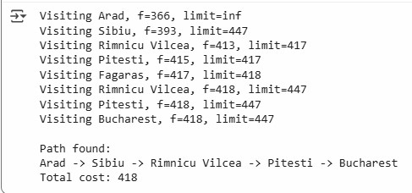

Practical No :3
Aim: Decision Tree Learning
- Implement the Decision Tree Learning algorithm to build a decision tree for a given dataset
- Evaluate the accuracy and effectiveness of the decision tree on test data
- Visualize and interpret the generated decision tree.
Code:
# Import necessary libraries import numpy as np import pandas as pd # Import Pandas for data loading import matplotlib.pyplot as plt from sklearn.tree import DecisionTreeClassifier, plot_tree from sklearn.model_selection import train_test_split from sklearn.metrics import accuracy_score
# Load the Iris dataset (iris.csv) # Replace 'iris.csv' with the actual path to your Iris dataset file data = pd.read_csv('/content/Iris.csv')
# Assuming the target variable is in a column named 'Target' X = data.drop('Target', axis=1) y = data['Target']
# Split the dataset into a training set and a testing set X_train, X_test, y_train, y_test = train_test_split(X, y, test_size=0.2, random_state=42)
# Create a Decision Tree classifier clf = DecisionTreeClassifier()
# Fit the classifier to the training data clf.fit(X_train, y_train)
# Make predictions on the test data y_pred = clf.predict(X_test)
# Calculate the accuracy of the model
accuracy = accuracy_score(y_test, y_pred) print(f"Accuracy: {accuracy:.2f}")
# Visualize and interpret the generated decision tree plt.figure(figsize=(12, 8)) plot_tree(clf, filled=True, feature_names=X.columns, class_names=data['Target'].unique()) plt.title("Decision Tree Visualization (Iris Dataset)") plt.show() Output:
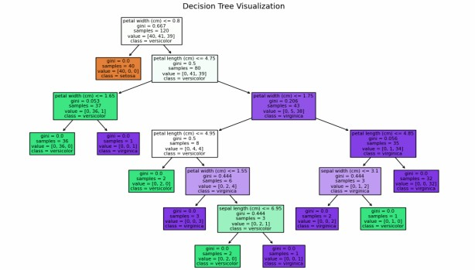

Practical No :4
Aim: Feed Forward Back propagation Neural Network
- Implement the Feed Forward Backpropagation algorithm to train a neural network.
- Use a given dataset to train the neural network for a specific task.
- Evaluate the performance of the trained network on test data
Program:
import numpy as np
# Define the sigmoid activation function and its derivative def sigmoid(x): return 1 / (1 + np.exp(-x))
def sigmoid_derivative(x): return x * (1 - x)
# Define the neural network class class NeuralNetwork: def __init__(self, input_size, hidden_size, output_size): # Initialize weights with random values self.weights_input_hidden = np.random.uniform(-1, 1, (input_size, hidden_size)) self.weights_hidden_output = np.random.uniform(-1, 1, (hidden_size, output_size))
def forward(self, inputs): # Forward propagation self.hidden_input = np.dot(inputs, self.weights_input_hidden) self.hidden_output = sigmoid(self.hidden_input) self.output_input = np.dot(self.hidden_output, self.weights_hidden_output) self.predicted_output = sigmoid(self.output_input) return self.predicted_output
def backward(self, inputs, target, learning_rate): # Backpropagation error = target - self.predicted_output delta_output = error * sigmoid_derivative(self.predicted_output) error_hidden = delta_output.dot(self.weights_hidden_output.T) delta_hidden = error_hidden * sigmoid_derivative(self.hidden_output)
# Update weights self.weights_hidden_output += np.outer(self.hidden_output, delta_output) * learning_rate self.weights_input_hidden += np.outer(inputs, delta_hidden) * learning_rate
def train(self, training_data, targets, epochs, learning_rate): for epoch in range(epochs): for i in range(len(training_data)):
inputs = training_data[i] target = targets[i] self.forward(inputs) self.backward(inputs, target, learning_rate)
def predict(self, inputs): return self.forward(inputs)
# Define XOR dataset training_data = np.array([[0, 0], [0, 1], [1, 0], [1, 1]]) targets = np.array([[0], [1], [1], [0]])
# Create and train the neural network input_size = 2 hidden_size = 4 output_size = 1 learning_rate = 0.1 epochs = 10000
nn = NeuralNetwork(input_size, hidden_size, output_size) nn.train(training_data, targets, epochs, learning_rate)
# Test the trained network for i in range(len(training_data)): inputs = training_data[i] prediction = nn.predict(inputs)
print(f"Input: {inputs}, Predicted Output: {prediction}")
Output:
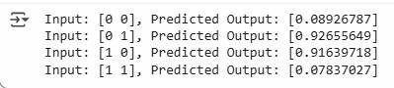

Practical No :5
Aim: Support Vector Machines (SVM)
1.Implement the SVM algorithm for binary classification.
2.Train an SVM model using a given dataset and optimize its parameters.
3. Evaluate the performance on test data and analyze the results.
Program:
import numpy as np import pandas as pd from sklearn.svm import SVC from sklearn.model_selection import train_test_split from sklearn.metrics import accuracy_score, confusion_matrix, classification_report
# Load dataset data = pd.read_csv("D:\\TYCS_DS\\Dataset\\Iris.csv")
# Display first few rows print("Dataset Preview:") print(data.head())
# Features and Target X = data.drop('Target', axis=1) y = data['Target']
# Split dataset
X_train, X_test, y_train, y_test = train_test_split(
X, y, test_size=0.2, random_state=42)
# Create SVM classifier svm_classifier = SVC(kernel='linear')
# Train model
svm_classifier.fit(X_train, y_train)
# Predict test data y_pred = svm_classifier.predict(X_test)
# Accuracy accuracy = accuracy_score(y_test, y_pred) print("\nAccuracy:", accuracy)
# Confusion Matrix print("\nConfusion Matrix:") print(confusion_matrix(y_test, y_pred))
# Classification Report print("\nClassification Report:") print(classification_report(y_test, y_pred)) Output:
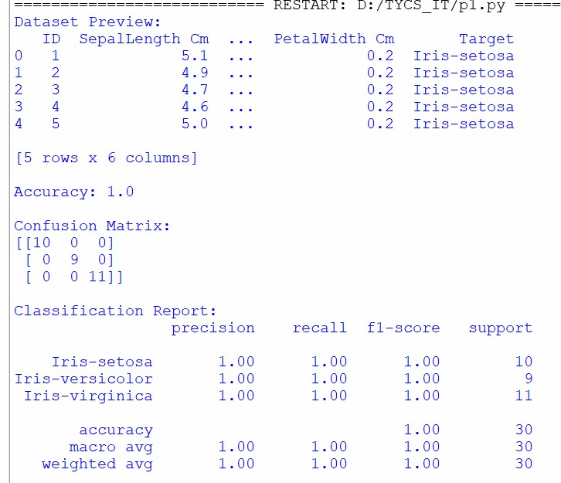
Program:
# Import required libraries from sklearn.datasets import load_breast_cancer from sklearn.model_selection import train_test_split from sklearn.preprocessing import StandardScaler from sklearn.svm import SVC from sklearn.metrics import accuracy_score, confusion_matrix, classification_report
# Load dataset data = load_breast_cancer()
# Features and Target X = data.data y = data.target
# Split dataset into training and testing sets
X_train, X_test, y_train, y_test = train_test_split(
X, y, test_size=0.2, random_state=42
)
# Feature Scaling scaler = StandardScaler()
X_train = scaler.fit_transform(X_train)
X_test = scaler.transform(X_test)
# Create SVM classifier svm_model = SVC(kernel='linear')
# Train the model
svm_model.fit(X_train, y_train)
# Make predictions y_pred = svm_model.predict(X_test)
# Evaluate model accuracy = accuracy_score(y_test, y_pred) print("Accuracy:", accuracy)
print("\nConfusion Matrix:") print(confusion_matrix(y_test, y_pred))
print("\nClassification Report:") print(classification_report(y_test, y_pred))
Output:
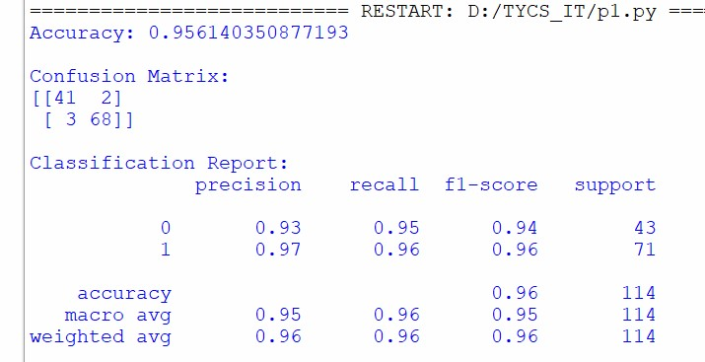

Practical No :6
Aim: Adaboost Ensemble Learning
1.Implement the adaboost algorithm to create an ensemble of weak classifiers.
2.Train the ensemble model on a given dataset and evaluate its performance.
3.Compare the results with individual weak classifier.
Program:
import pandas as pd import matplotlib.pyplot as plt from sklearn.model_selection import train_test_split from sklearn.tree import DecisionTreeClassifier from sklearn.ensemble import AdaBoostClassifier from sklearn.metrics import accuracy_score, classification_report
# Load Dataset data = pd.read_csv("D:\\TYCS_DS\\Dataset\\Iris.csv")
# Features and Target X = data.drop('Target', axis=1) y = data['Target']
# Split Dataset
X_train, X_test, y_train, y_test = train_test_split(
X, y, test_size=0.2, random_state=42)
# Weak Classifier (Decision Tree Stump) weak_classifier = DecisionTreeClassifier(max_depth=1) weak_classifier.fit(X_train, y_train) weak_pred = weak_classifier.predict(X_test) weak_accuracy = accuracy_score(y_test, weak_pred) print("Weak Classifier Accuracy:") print(weak_accuracy) # AdaBoost Ensemble Model
adaboost_model = AdaBoostClassifier( estimator=DecisionTreeClassifier(max_depth=1), n_estimators=50, random_state=42
)
adaboost_model.fit(X_train, y_train) ada_pred = adaboost_model.predict(X_test) ada_accuracy = accuracy_score(y_test, ada_pred)
print("\nAdaBoost Accuracy:") print(ada_accuracy)
print("\nClassification Report (AdaBoost):") print(classification_report(y_test, ada_pred))
# Performance Comparison print("\nPerformance Comparison")
print("----------------------")
print("Weak Classifier Accuracy :", weak_accuracy) print("AdaBoost Accuracy :", ada_accuracy)
# Plot Accuracy Comparison Graph models = ['Weak Classifier', 'AdaBoost'] accuracies = [weak_accuracy, ada_accuracy] plt.figure(figsize=(6, 4)) plt.bar(models, accuracies)
plt.title('Accuracy Comparison: Weak Classifier vs AdaBoost') plt.xlabel('Models') plt.ylabel('Accuracy') plt.ylim(0, 1.1)
# Display accuracy values on bars for i, value in enumerate(accuracies): plt.text(i, value + 0.02, f'{value:.2f}', ha='center') plt.show() Output:
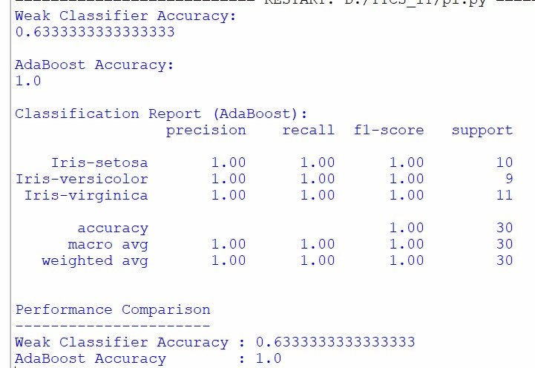
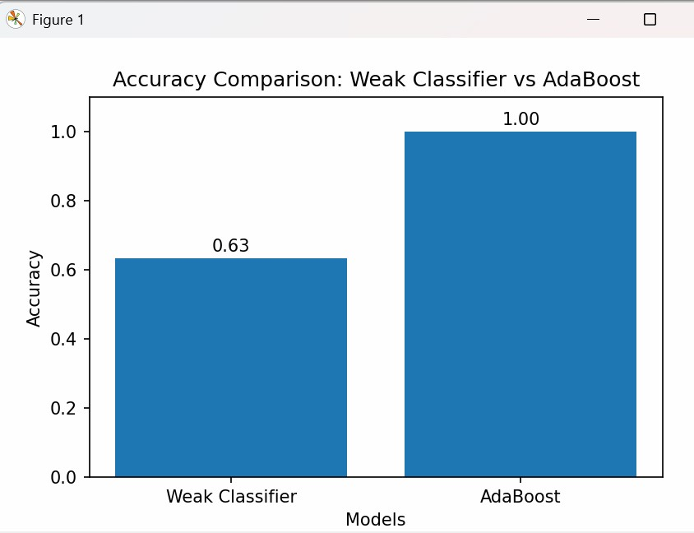

Practical No :7
Aim: Naïve Bayes Classifier
- To implement the Naive Bayes algorithm for classification.
- Train a Naive Bayes model using a given dataset and calculate class probabilities.
- Evaluate the accuracy of the model on test data and analyze the results.
Program:
import pandas as pd from sklearn.datasets import load_iris from sklearn.model_selection import train_test_split from sklearn.naive_bayes import GaussianNB from sklearn.metrics import accuracy_score, confusion_matrix, classification_report
# Load Iris Dataset iris = load_iris()
X = iris.data y = iris.target
# Split dataset into Training and Testing sets
X_train, X_test, y_train, y_test = train_test_split(
X, y, test_size=0.2, random_state=42
)
# Create Naive Bayes Classifier clf = GaussianNB()
# Train Model
clf.fit(X_train, y_train)
# Predict Test Data y_pred = clf.predict(X_test)
# Calculate Class Probabilities probabilities = clf.predict_proba(X_test)
print("Class Probabilities for first 5 test samples:") print(probabilities[:5])
# Model Accuracy accuracy = accuracy_score(y_test, y_pred) print("\nAccuracy:", accuracy)
# Confusion Matrix print("\nConfusion Matrix:") print(confusion_matrix(y_test, y_pred))
# Classification Report print("\nClassification Report:") print(classification_report(y_test, y_pred))
Output:
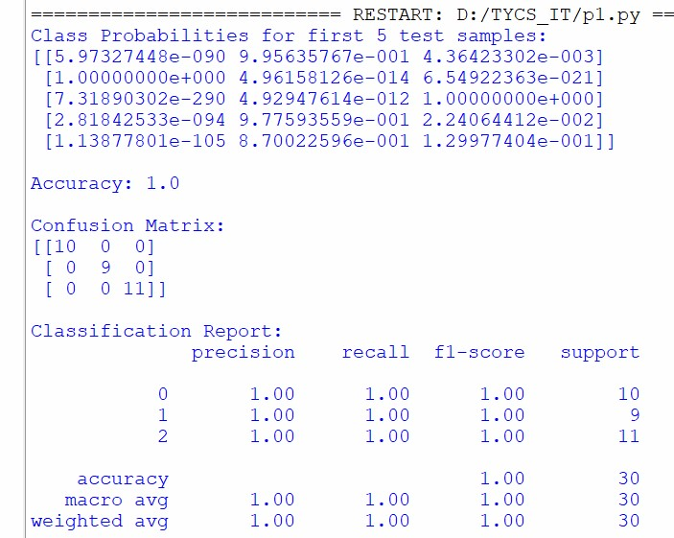
Program:
from sklearn.model_selection import train_test_split from sklearn.naive_bayes import GaussianNB from sklearn.metrics import accuracy_score import pandas as pd # Load the football dataset from CSV dataset = pd.read_csv('/content/argfrc_dataset.csv') # Separate features (X) and labels (y) X = dataset[['Argentina', 'France']].values y = dataset[' '].values
# Split the dataset into training and testing sets X_train, X_test, y_train, y_test = train_test_split(X, y, test_size=0.2, random_state=42) # Create a Naïve Bayes classifier (Gaussian Naïve Bayes for continuous features) clf = GaussianNB() # Train the classifier on the training data clf.fit(X_train, y_train) # Make predictions on the test data y_pred = clf.predict(X_test)
# Calculate and print the accuracy accuracy = accuracy_score(y_test, y_pred) print("Accuracy:", accuracy) Output:


Practical No :8
Aim: K - Nearest Neighbors (K-NN)
- Implement the K-NN algorithm for classification or regression.
- Apply the K-NN algorithm to a given dataset and predict the class or value for testdata.
- Evaluate the accuracy or error of the predictions and analyze the results
Program:
import pandas as pd import matplotlib.pyplot as plt from sklearn.datasets import load_iris from sklearn.model_selection import train_test_split from sklearn.neighbors import KNeighborsClassifier from sklearn.metrics import accuracy_score, confusion_matrix, classification_report
# Load Iris Dataset iris = load_iris()
X = iris.data y = iris.target
# Split Dataset into Training and Testing Sets
X_train, X_test, y_train, y_test = train_test_split(
X, y, test_size=0.2, random_state=42
)
# Create K-NN Classifier knn = KNeighborsClassifier(n_neighbors=5)
# Train the Model knn.fit(X_train, y_train)
# Predict Test Data y_pred = knn.predict(X_test)
# Calculate Accuracy accuracy = accuracy_score(y_test, y_pred) print("Accuracy:", accuracy)
# Confusion Matrix print("\nConfusion Matrix:") print(confusion_matrix(y_test, y_pred))
# Classification Report print("\nClassification Report:") print(classification_report(y_test, y_pred))
# Predict Class for First Test Sample sample_prediction = knn.predict([X_test[0]]) print("\nPrediction for First Test Sample:", sample_prediction[0])
# -----------------------------
# Accuracy Graph
# ----------------------------plt.figure(figsize=(5,4)) plt.bar(['K-NN'], [accuracy]) plt.title('K-NN Classification Accuracy') plt.ylabel('Accuracy') plt.ylim(0, 1.1) plt.text(0, accuracy + 0.02, f'{accuracy:.2f}', ha='center') plt.show() Output:
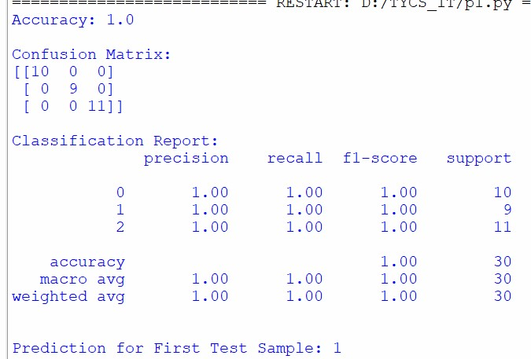

Practical No :9
Aim: Association Rule Mining
- Implement the Association Rule Mining algorithm (e.g., Apriori) to find frequentitem sets.
- Generate association rules from the frequent itemsets and calculate their supportand confidence.
- Interpret and analyze the discovered association rules.
Program:
!pip install mlxtend from mlxtend.frequent_patterns import apriori from mlxtend.frequent_patterns import association_rules import pandas as pd dataset =[ ['milk','bread','nuts'],
['milk','bread'],
['milk','eggs','nuts'],
['milk','bread','eggs'],
['bread','nuts'] ] df = pd.DataFrame(dataset) df_encoded = pd.get_dummies(df,prefix='',prefix_sep='') frequent_itemsets = apriori(df_encoded,min_support=0.6,use_colnames=True) print("Frequent Itemsets:") print(frequent_itemsets) rules = association_rules(frequent_itemsets,metric='confidence',min_threshold=0.7) print("\nAssociation Rules:") print(rules) Output:
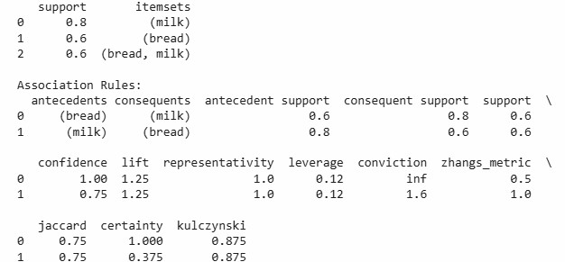

Practical No :10
Aim: Demo of open AI and TensorFlow Tools
- Explore and experiment with OpenAI or TensorFlow tools and libraries.
- Perform a demonstration or mini-project showcasing the capabilities of the tools.
- Discuss and present the findings and potential applications.
Practical: # Import Libraries import tensorflow as tf from tensorflow.keras.datasets import mnist from tensorflow.keras.models import Sequential from tensorflow.keras.layers import Dense, Flatten from sklearn.metrics import accuracy_score import matplotlib.pyplot as plt
# Load MNIST Dataset
(X_train, y_train), (X_test, y_test) = mnist.load_data()
# Normalize Data
X_train = X_train / 255.0
X_test = X_test / 255.0
# Create Neural Network Model model = Sequential([
Flatten(input_shape=(28, 28)),
Dense(128, activation='relu'),
Dense(10, activation='softmax')
])
# Compile Model model.compile( optimizer='adam', loss='sparse_categorical_crossentropy', metrics=['accuracy'] )
# Train Model model.fit(X_train, y_train, epochs=5)
# Evaluate Model loss, accuracy = model.evaluate(X_test, y_test) print("Test Accuracy:", accuracy)
# Predict First Test Image prediction = model.predict(X_test[:1]) print("Predicted Digit:", prediction.argmax())
# Display Image plt.imshow(X_test[0], cmap='gray') plt.title("Test Image") plt.axis('off') plt.show() Output:

